

TabScore2

User Guide

Version 1.1.0

Table of Contents
Description and Features 3
What is TabScore2? 3
Features 4
Prerequisites 5
Charging Tablets 6
Installation 7
Install Software 7
Configure the Network 7
Set Up Tablets 8
Modify the Scoring Program 9
Firewall 9
Using TabScore2 10
Differences to TabScore 10
Overview 10
Hand Record File and Settings 10
Registering Tablets 11
Player ID Numbers and Names 11
Entering Contracts and Results 12
Manually Entering Hand Records 13
Viewing Hand Records 13
Viewing the Ranking List 14
Movement and Finishing the Event 15
Making Corrections and Troubleshooting 16
Making Manual Score Adjustments 16
Correcting Player Names 16
Corrections and Errors Requiring Tablet Re-registration 17
Network or Database Connection Problems 17
Server or Wifi Connection Stops Working 17
Advanced Debugging 18
Appendix 1 – Settings in TabScore2 19
Appendix 2 – TabScore2 Workflow Diagram 22
Appendix 3 – Setting Up Tablets 23
Appendix 4 – Setting Up Kindles 24

Description and Features

What is TabScore2?
Over the years, Bedford Bridge Club used a variety of scoring (ScoreBridge, EBUScore, JSSScore) and wireless scoring (BridgePad, BridgeTab) software. Having settled on EBUScore for our scoring program, we found that there was no wireless scoring software that met our requirements for functionality, ease of use, robustness and price. So, in 2018, Peter Flippant sat down and wrote TabScore to meet those requirements. Since then, the Microsoft technology that underpinned TabScore has moved on. TabScore2 is a development of TabScore that uses that new technology but provides essentially the same user experience as TabScore.
TabScore2 is a Microsoft Windows application that creates web pages and serves those web pages across a local wireless network. Unlike most wireless scoring systems, TabScore2 uses modern thin-client architecture that provides consistent data by using a single scoring database. That database is a Bridgemate .bws standard Access database, so TabScore2 is a direct replacement for BridgeTab (or Bridgemate, BridgePad etc) and it should work with any scoring software that can run Bridgemates.
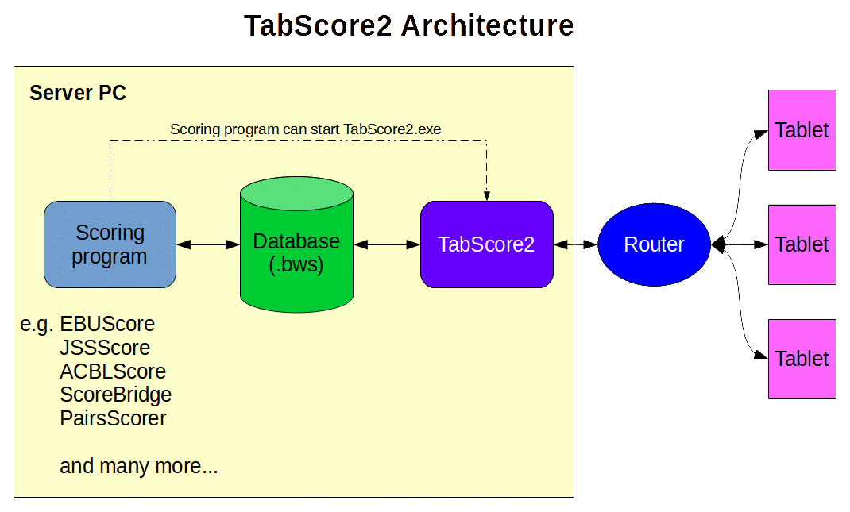

TabScore2 requires a server PC or laptop computer, a wireless router, and some sort of table-top device with a browser on each table (tablet, Kindle, phone, etc). In the rest of this document, these table-top devices will be referred to as tablets. TabScore2 can run in 3 modes:
- Traditional Mode in which there is a dedicated tablet on each table, in the same way that Bridgemates operate. This works best if the bridge club has a set of scoring tablets and can put one on each table. Bedford Bridge Club has a set of 18 seven-inch tablets that are used only for scoring.
- Personal Mode in which the tablets move with the players. This is ideal for those clubs that don't want to invest in dedicated hardware, but whose members are willing to use their own phones or tablets. A tablet or phone is required by every player who is involved in entering scores. This means that 2 tablets per table (ostensibly North and East) are required for one-winner pairs movements and 4 tablets per table are required for individual events. For teams and two-winner pairs movements, the 2 modes are identical and only one tablet per table (North) is needed.
- Scorer Mode which is similar to Personal Mode but allows the scorer at the table to be chosen each round. This is useful if not every pair or player has a tablet, when TabScore2 can capture the scores whenever at least one pair or player at the table has a tablet (with any missing scores then having to to be entered directly into the scoring program).
Other than a browser, no special software is needed on the tablets, although some customization of the tablets will provide a better user experience. See later in this Guide for more details of how we do this at Bedford Bridge Club.
TabScore2 is currently available in English, Spanish, German and Dutch. It will default to English if the Windows native language is not supported. If you would like to have TabScore2 in a different language and are willing to help with the translation, then please contact the developers.
For those interested in the technical specification, TabScore2 is written using .NET 8, C# and MVC, and the web pages use HTML5 and Bootstrap 5 for formatting, and some basic JavaScript. It makes use of the built-in .NET 8 web server called Kestel; this means that (unlike the original TabScore) both the Windows user interface and the web server are contained in a single application. TabScore2 is a 64-bit application, although it still requires a 32-bit sub-process (called GrpcBwsDatabaseServer) to read and write to the aniquated .bws database. The source code for TabScore2 is available on GitHub (https://github.com/pjflip/TabScore2).

Features
TabScore2 can be used to score pairs, teams, Swiss events, and individual events provided the scoring software supports them. It is currently configured for club use and is limited to 4 sections (A, B, C and D in that order) and 30 tables per section. It offers a range of options that can be set either via the scoring software or by using TabScore2 Settings. In particular, TabScore2 offers:
- The option to either to import deal files or enter hand records manually, and then the option to display hand records on the tablets. A hand record can be viewed from different perspectives, depending on the Mode in use and the number of tablets being used at the table. The hand record display uses Bo Haglund's Double Dummy Solver (DDS) to analyse hand records, and can display the makeable contracts.
- The option to enter results as either total tricks won or +/-/= against the contract.
- The option to enter a lead card and validate that lead card against the hand record.
- The option to display the pairs or individual ranking list at the end of each round, or at the end of the event. The ranking list display can be suppressed for a number of rounds, both at the start and end of the event.
- The option to use either or both of an internal (provided by the scoring program) or external player database of names and player ID numbers. This is useful if your national bridge organization, like the EBU, provides a database of membership ID numbers.
- The option to display a countdown timer to show the time left to the end of the round. The time per round can be set as a combination of Minutes per Board and Additional Minutes Per Round. The timer starts a round when the first table reaches the Show Boards screen for that round.
- The option to display splash screen on the server PC during startup. On old hardware, this might provide some reassurance that something is happening when the application startup process might take some time. On faster PCs, it is not needed and should be disabled.
The Tradional/Personal/Scorer Mode setting can only be changed before the scoring session starts. All other settings be changed during a session, and changes will take effect in TabScore2 either immediately or at the beginning of the next round as appropriate.
The TabScore2 main form also has a button to allow the viewing and editing of previously entered results. This is useful if the scoring program either does not provide that facility, or if the scoring program does not write amended or adjusted scores to the scoring database (and most do not).
If the tablet and browser support the functionality, TabScore2 will display a battery level indicator (in the top right of the screen).

Prerequisites
TabScore2 has been developed for a server PC running Windows 10+ and .NET 8. Bo Haglund's DDS requires the Microsoft Visual C++ Redistributable 2015 (or later) to be installed on the PC. See the Installation section below for more information.
A local wireless (Wi-Fi) network, ideally using a dedicated router and network. However, the system should run over a pre-existing Wi-Fi network without any problem.
Tablets, phones or other devices with an internet browser that supports Javascript (ie any mainstream browser). Because TabScore2 uses Bootstrap 5, the browser and tablet operating systems must meet certain minimum standards. For Android, this means version 6.0+. Please check here for more details: getbootstrap.com/docs/5.0/getting-started/browsers-devices. For an Android full-screen locked-down browser, Fully Kiosk Browser (https://www.ozerov.de/fully-kiosk-browser/) has been used successfully at Bedford Bridge Club. Please note that there have been some minor issues when using the Silk browser on Fire devices, and Silk is not recommended.
A scoring program that creates a Bridgemate-compatible scoring database (.bws file). Examples include EBUScore, JSSScore, ACBLscore, ScoreBridge, BridgeScorer, BridgeGem, CompScore3, and RuderSyv. The most recent versions of EBUScore and JSSScore incorporate a 'TabScore' scoring option which, when set up, will work with TabScore2.

Charging Tablets
Another issue to consider with Traditional Mode using dedicated tablets is charging. The tablets in use at Bedford Bridge Club will generally last 2 sessions of bridge between charging, and it is worth investing in good quality tablets to obtain a long battery life. We have adopted a system using battery packs. We charge up the battery packs during the bridge session, and then use the battery packs to re-charge the tablets overnight. This avoids the need to leave the tablets charging unattended on mains power. The picture overleaf shows the charging boxes we use with tablets and battery packs.


Installation
The installation and set-up of TabScore2 is significantly easier than for TabScore. Nonetheless, it still requires some understanding of how your PC and network operates. Please make sure you read and understand the installation instructions thoroughly before proceeding.

Install Software
.NET 8 Runtime Libraries
There are 3 .NET 8 runtime libraries (ASP.NET Core Runtime 8, .NET Desktop Runtime 8 and .NET Runtime 8), and TabScore 2 requires both the 32-bit (x86) and 64-bit (x64) versions (so 6 runtime libraries in total). To check if these are installed, look in the appropriate folders in
"C:\Program Files(x86)\dotnet\shared\"
and
"C:\Program Files\dotnet\shared\".
If not installed, they can be downloaded from Microsoft at https://dotnet.microsoft.com/en-us/download/dotnet/8.0.
Microsoft Visual C++ Redistributable
Bo Haglund's DDS needs the Microsoft Visual C++ Redistributable (x64) 2015 (or later) to be installed on the PC. To check if this is already installed, go to Control Panel/Programs/Programs and Features, and see if it is listed as an installed program.
If necessary, search the Microsoft website for a suitable installer (it will have a name like vc_redist.x64.exe), or use this link: https://aka.ms/vs/17/release/vc_redist.x64.exe.
TabScore2 Software
The TabScore2 software can be installed by running TabScore2Setup.exe. This will create all the necessary files, shortcuts, etc, and will also create an uninstaller. Alternatively, you can simply copy the TabScore2 folder (and all its sub-folders) to C:\Program Files.

Configure the Network
Various network configurations are possible, and this guide cannot consider all possibilities. The essential requirement is that the tablet browsers can consistently find the server PC across the network. The simplest approach is to use a static IP address for the server PC, and the rest of this guide assumes this is the approach taken. An alternative would be to use a DNS server on your network, possibly in the router – if you choose this latter approach, we'll assume you know what you're doing!
A static IP address can often be set on the router:
- Log on to the router and set a DHCP device reservation (static IPv4 address) for the server PC. If there is no other network, an IP address something like 192.168.0.100 is probably suitable
- Setting a DHCP reservation may require the PC's physical MAC address. This can be found by opening a command prompt (cmd.exe) and typing 'ipconfig /all'
If your router does not support DHCP device registration (and many don't), you can go to the router network's settings via the PC's Control Panel, select Properties/Internet Protocol Version 4 (TCP/IPv4)/Properties and specify the IP address you require. When doing this, the default gateway is normally the IP address of the router, as is the preferred DNS server; setting 8.8.8.8 for the alternative DNS server usually works.
It is possible to have the server PC connected to the internet via one network and TabScore2 connected via another. This would require 2 networks cards (Wi-Fi or Ethernet). A configuration that has worked successfully at Bedford Bridge Club is internet on Wi-Fi (using subnet 192.168.0.xxx) and the TabScore2 router on Ethernet (using subnet 192.168.10.xxx and a static IP address of 192.168.10.101 for the PC).

Set Up Tablets
Connecting the Tablets via WiFi
As mentioned previously, the tablets do not need any form of special configuration to run TabScore2 – just a web browser. Each tablet must obviously be connected to the same WiFi network as the server PC. The browser on each browser will need to point to the TabScore2 URL. This URL is the IP address of the server PC followed by :5213 (so the URL should look something like http://192.168.0.100:5213). The ‘5213’ part of the URL is the port on which the TabScore2 Kestrel web server listens for requests.
IMPORTANT: The original TabScore used IIS as its web server. The TabScore set-up was therefore more complicted, but it did mean that the TabScore StartScreen home web page was available as soon as the server PC was running. Using the .NET 8 Kestrel web server simplifies TabScore2’s set-up and operation, but it does mean that the TabScore2 StartScreen web page can only be accessed once the TabScore2 application is running. Entering the TabScore2 URL into a browser before the application has started will likely give either a blank screen or an http error response (404 Not Found or 408 Request Timeout). Users who are familiar with TabScore will need to be made aware of this and will need to change their habits!
Tablet Configuration
If using Traditional Mode with dedicated tablets, it may help to configure and lock down the tablets to some extent, so that the user is presented with a simple start-up screen. For example, it makes sense to set the TabScore2 URL as the home page in the tablet's browser, or at least set a favourite that points to the TabScore2 URL. The tablets in use at Bedford Bridge Club have been set up with the Fully kiosk browser to run in full screen mode. The configuration of this and other tablet software used at Bedford Bridge Club is given in Appendix 3.
Thanks to innovative work by Tony Ferneyhough, TabScore2 has also been set up to run on Kindle Fire tablets. Information on configuring Kindles is given in Appendix 4. The information in both Appendices is indicative only, and the best way to set up the tablets will depend very much on the make and model of tablet, and it's operating system.
If using Personal Mode, then every player who is going to do scoring will need to set up the browser in their personal tablet or phone to point to the TabScore2 URL. Again, the simplest approach would be for them to set a favourite that points to the TabScore2 URL. But if you can persuade your players to download, install and configure the Fully kiosk browser, it would give them a dedicated app to run TabScore2.

Modify the Scoring Program
The scoring program needs to start TabScore2.exe as its wireless scoring software. How this is done varies considerably by scoring program.
In EBUScore (provided you have a recent version), go to the Event menu for any event and then the Table Top Unit Scoring screen. This might be called something else if the program is currently configured for some other wireless scoring software. From here you can set the Table Top Unit to TabScore using the drop-down list. Then using the Admin tab and the Set TabScore Program Location button, set it to:
C:\Program Files\TabScore2\TabScore2.exe
For other scoring programs, please see your scoring program documentation.

Firewall
Both TabScore2 and GrpcBwsDatabaseServer require access through any firewall. If using Windows Defender Firewall, you will be propted to allow these programs through the firewall the first time you run them. If you are using a third party firewall (maybe as part of an anti-virus or security suite of programs), you may need to create inbound rules to allow TabScore2 and GrpcBwsDatabaseServer to run.

Using TabScore2

Differences to TabScore
If you are familiar with TabScore, you will find that TabScore2 operation is very similar. The main differences are in the start-up procedure.

Overview
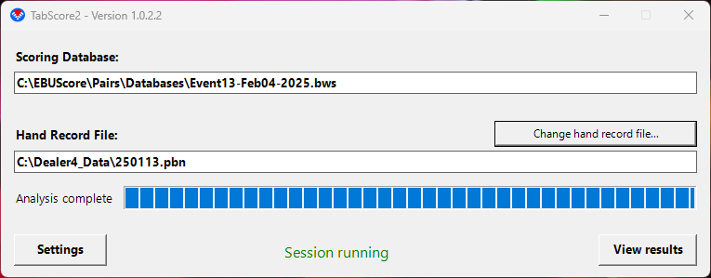
Once the event organizer has used the scoring program to set the movement, create the scoring database, and launch TabScore2, the TabScore2 main form will show on the PC. TabScore2 will perform a double dummy analysis of any hand records and will then indicate that the session is running. Players will then be able to use their tablets’ browsers to navigate to the TabScore2 Start Screen (the TabScore2 URL discussed above).
From there, players will then be able to register their tablets, enter their player ID numbers, and then proceed to enter contract details and results for each round of the movement and each board. A diagram showing the flow through the various TabScore2 screens is at Appendix 2.
In general, a TabScore2 Enter or Edit button allows users to enter or change details, a View button allows viewing but not editing, and the OK button moves on to the next screen when all details have been entered. In many cases, there is also a Back button that goes back to the previous screen.

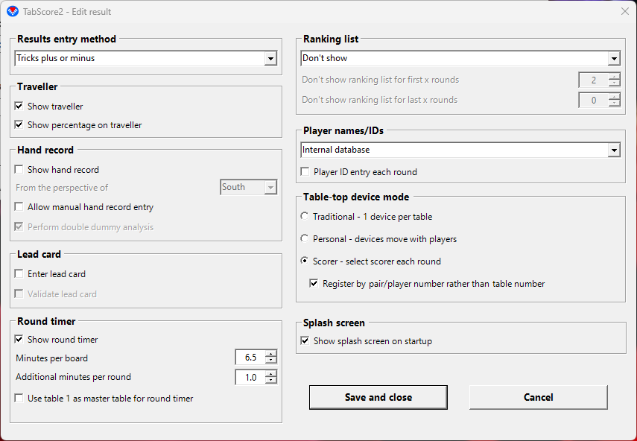
Hand Record File and Settings
The event organizer would normally set the hand record file and settings for the event by using the scoring program. However, a hand record file (in PBN format) can also be added or changed from the TabScore2 main form.
TabScore2 will use any applicable settings added to the scoring database by the scoring program, but there is also a Settings button on the TabScore2 main form that can be used to override these settings. There are 5 settings which can only be set via the Settings button: Table-top Device Mode (Tradional, Personal or Scorer); the Round Timer; Double Dummy analysis of manually entered hand records; Hand Record Perspective; and Splash Screen. The values for these settings, and any other setting not in the scoring database, will persist from session to session.

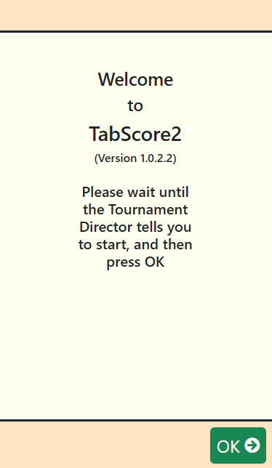
Registering Tablets
From the Start Screen on the tablets, players will be able to register their tablets by entering their section and table numbers (TabScore2 defaults to Section A if there is only one section). If in Personal Mode or Scorer Mode with moving tablets, players will also be prompted to enter their direction. TabScore2 uses the movement information in the scoring database to allocate pair numbers (or player numbers for individual events). In Scorer Mode only, there is also a setting that allows players to register by section and pair/player number directly (assuming players have been allocated these at the start).

Player ID Numbers and Names
Player ID numbers and/or names can be set within the scoring program before creating the scoring database. However, it is normally easier to let the players enter their own player ID numbers into TabScore2 at their tables.
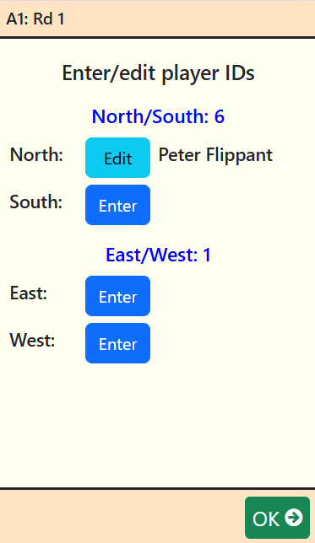
How TabScore2 resolves player ID numbers to names is determined by a setting. Names can come from either an internal database of player names/numbers set up within the scoring program, or from an external database (as, for example, provided by your national bridge organization), or both. It is usual for numbers in the internal database to be in the range 1-9999 and for 10000+ for the external database.
If a player doesn't have or doesn't know their ID number, TabScore2 provides the option to enter Unknown. Internally, this sets a value of 0, so 0 should not be used as an actual player number. Names can be updated or corrected within the scoring program at any time (see Correcting Player Names below).
In Traditional Mode, all player ID numbers at the table are entered by the scorer (usually North). In Personal Mode, each player with a tablet is responsible for entering their own (and for pairs, their partner's) player IDs. TabScore2 won't allow any player at the table to move past the Enter/Edit Players screen until all players at the table have been entered.
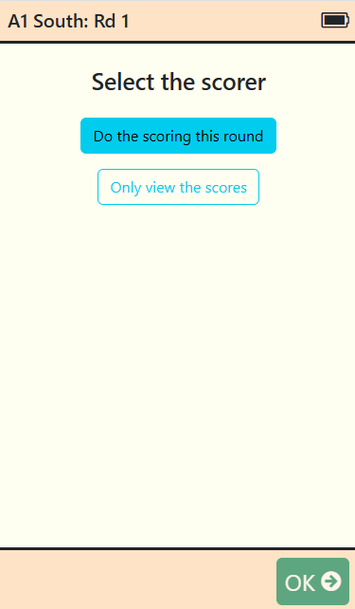
If using a movement where not all players are seated at tables for the first round (such as a rover, or an incomplete individual), TabScore2 will capture the player numbers for any additional players at the first opportunity (usually the second round) and add them to the database. However, some scoring programs (such as EBUScore) may also need to have these additional players added manually.
For certain events (such as pivot teams and teams events where team members can be swapped in and out), you may need to change player names during the course of the event. TabScore2 can do this via a setting that requires player ID number entry each round. Whilst TabScore2 will update the database with the new names, it is worth checking that your scoring program correctly retrieves these names.
In Scorer Mode only, at the start of each round, there will be a prompt on each tablet to select the scorer. One and only one tablet at the table must be selected to be the scorer. TabScore2 will not allow the ‘Only view the scores’ option to be selected until one of the tablets at the table has been selected as scorer.

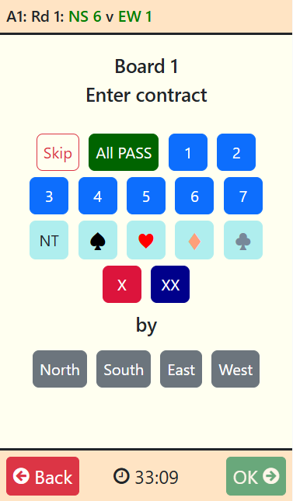
Entering Contracts and Results
TabScore2 shows a screen with all the boards to be played in the current round. Contract details, optionally lead cards, and results can be entered for these boards in any order by tapping on the appropriate Enter button. Previously entered contract details and results can be viewed or amended up until the end of the round by tapping on a View or an Edit button. This allows players at the table to confirm all the results for the round.
To skip a board (ie not play the board in the current round), tap the Skip button from the Enter Contract screen and OK. This might be necessary if the Tournament Director decides to remove a board or plans to make a subsequent manual or artificial adjustment. You have to enter a result (or skip) for each board before you can proceed to the next round.
In Personal Mode, only one tablet per table (North) is actually used for entering scores. The tablets for other directions will only allow players to view results once they have been entered.
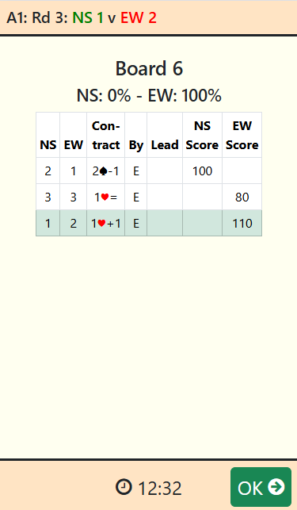
If the setting to show the traveller has been selected, TabScore2 will show the traveller (all the results entered so far for this board). TabScore2 can only show results from the database, so results that have been entered or manually adjusted within the scoring program and not written to the database may not show correctly on the traveller. If you wish players to see manually adjusted results in the traveller (including artificial adjusted percentages), you can use the View results button in the TabScore2 main form to make the score adjustments (see the section on Making Manual Score Adjustments below).

Manually Entering Hand Records
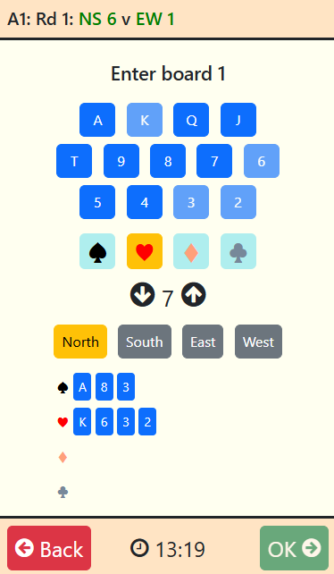
If the setting to enter hand records manually has been applied, then the first time a board is played TabScore2 will display a screen to do this. If you are short of time, then clicking on 'Skip' (not shown here) will move on, but the same screen will be displayed the next time the board is played. The 'Skip' button disappears once you start to enter cards.
Hand records are entered by selecting the direction (North, South, East of West) and then the suit, and then by clicking on the appropriate cards. North and Spades are selected by default. The selected cards will be shown at the bottom of the screen for the selected direction. Clicking on a previously selected card will remove it.
Once 13 cards have been entered for each of 3 directions, an 'All' button will appear for the remaining direction. Clicking on this will add the remaining 13 cards for that direction. Once all 52 cards have been entered, the OK button is enabled.

Viewing Hand Records
If a hand record exists (either from a file or entered manually) and you have selected the setting to view hand records, TabScore2 will allow you to view the hand records and makeable contracts (TabScore2 uses Bo Haglund's double dummy solver to do the analysis). On the Traveller Screen, you will see a cards symbol – click on this to open the Hand Record screen.
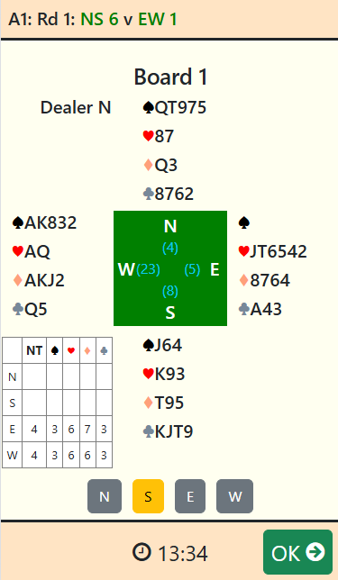
There is a setting to set the default perspective, namely the direction that shows at the bottom of the screen. The default is from South’s perspective, but this may be different if in Personal Mode. There are also buttons on the screen to change the perspective at any time. For an individual event in Personal Mode, the hand record will always be shown from the player's own perspective.

Viewing the Ranking List
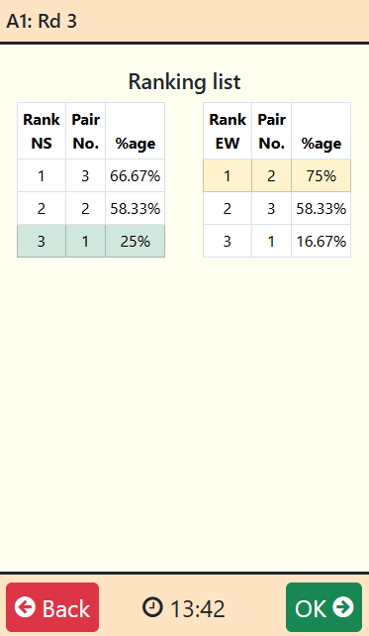
TabScore2 provides a setting to view a ranking list, either at the end of each round or at the end of the event. Obviously this is only useful for pairs and individual events, and it is recommended that this option not be used for teams or Swiss events. For pairs, some scoring programs (such as EBUScore) populate a database table with the ranking list data; TabScore2 uses this and so will show exactly the same ranking list that the scoring program does. The ranking list will automatically refresh every 10 seconds.
If ranking list data is not available, TabScore2 will make an attempt to calculate rankings based on a matchpoint calculation using the Neuberg formula. This ranking list may therefore differ from the one shown by your scoring programme if simple match-pointing or some alternative scoring method is being used. Also, TabScore2 can only take account of any manually adjusted or artificial scores in its ranking calculations if these have been written to the database, either by the scoring program or by using the TabScore2Starter View Results button. Nonetheless, the calculated ranking list can be a useful indicative guide to players during the event.

Movement and Finishing the Event
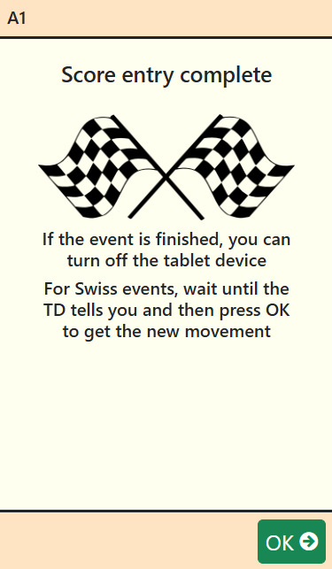
Between rounds TabScore2 will display the movement information, and a screen to confirm the players and boards for the next round. In Personal Mode, it is not possible to proceed beyond the Show Move screen until all pairs/players at the next table (or the current table if stationary) are ready to move.
Once the event is over, or the round is over for Swiss events, TabScore2 will display an End Screen, indicating that score entry is complete. This encourages the players to switch off the tablet, but the tablet can safely be switched off before reaching the End Screen as all the data is stored on the server PC.
As the screen explains, for Swiss events, once the draw for the next round has been made and the movement information is available, tapping the End screen OK button will bring up the movement for the next round.

Making Corrections and Troubleshooting
Things can go wrong during the scoring process, either as a result of user error or a problem with the server PC or network connection. The thing to remember is that all the data is stored on the PC, and TabScore2 merely shows a view of that data. So, as long as the PC is still working, no data will be lost. Thus, for example, it is always possible to resume scoring a previously aborted session simply by loading an existing database into the scoring program and launching TabScore2. Likewise, it is easy to replace a tablet (if the battery runs out, for example), just by registering at the same table (and direction in Personal Mode) with a new tablet.

Making Manual Score Adjustments
Once a result has been entered in TabScore2 (including a skip), it may be necessary to make a score adjustment, either to correct a scoring error or to implement a Tournament Director ruling. There are a couple of options for making manual adjustments to the score.
One option would be to use your scoring program to make the score adjustment, and most scoring programs have the facility to do this. However, be aware that some scoring programs (including EBUScore) do not update the scoring database with these adjustments by default (please see the documentation for your own particular scoring program). Thus any score adjustments would not show in TabScore2, either in the Show Boards screen, the Traveller screen or in any calculation of the ranking list. Of course this may not matter as the scoring program will still be correct.
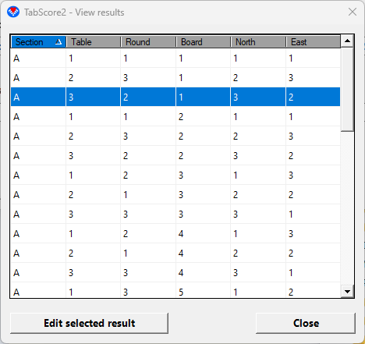
An alternative is to use the TabScore2 main form to make changes directly to the scoring database. Clicking on the View Results button brings up a list of previously entered results. This list can be sorted by clicking on the appropriate column header. Selecting a result and clicking on the Edit Selected Result button allows a range of score adjustments to be made. Whilst these do not cover the full range of possible adjustments allowed under the Laws of Bridge, they cover the more usual adjustments including artificial adjusted scores of Average- (40%), Average (50%) and Average+ (60%), and also results accidentally played in the wrong direction (arrow switched). Artificial adjusted scores and wrong direction are set using the Remarks drop-down list. Adjustments made in this way will show in TabScore2, and should also be read by the scoring program.

Correcting Player Names
If the user makes an error when entering a player ID, there is usually a chance to correct the entry before the data is committed (using the Edit button). However, once the user has moved past the Show Player IDs screen, any corrections will need to be done via the scoring program. However, be aware that some scoring programs do not automatically update the scoring database by default, and so these name corrections may not be available to TabScore2. In particular, in EBUScore, you will need to use the Write Names button on the TabScore Scoring screen to update any name changes to the database. Please see the documentation for your own particular scoring program.

Corrections and Errors Requiring Tablet Re-registration
There are a few user input errors that cannot be corrected using the software, for example entering the wrong section or registering to the wrong table (or section or direction). These issues can generally be resolved by returning the tablet or tablets to the TabScore2 Start Screen, and then re-registering correctly.
The procedure for getting to the Start Screen will depend on the browser. There may, for example, be a Home button or a favourite. For the full-screen version of the Fully Kiosk browser, the procedure is usually to swipe right to get to the menu, and then tap on Goto Start URL.
From the Start Screen, tapping OK allows you to re-select the table (and section and direction if appropriate). If you have already registered for a different location, you will get a warning; however, if you are re-registering at the correct location, it is safe to proceed. When you have re-registered, TabScore2 will take you to the beginning of the last round for which scores have been entered. This allows you to check, if necessary, that the scores have all been entered correctly before proceeding to the next round.

Network or Database Connection Problems
TabScore2 attempts to detect if there is any problem with the network or database connection for any one tablet. If this happens, TabScore2 will show an Error screen, and it will prompt the user to re-register the tablet. Usually such problems are rare and temporary, so re-registering will resolve the issue. In Personal Mode, you should re-register at your current location (section, table and direction) and not your original starting location.
If the server PC is still running, when you have re-registered, TabScore2 will be able to resume at the correct place. If not, once the server PC has been restarted, TabScore2 will take you to the beginning of the last round for which scores have been entered. This allows you to check, if necessary, that the scores have all been entered correctly before proceeding to the next round.

Server or Wifi Connection Stops Working
The server PC or Wifi router may stop working for some reason. A common scenario is when a laptop left running on battery power decides to shut itself down. If this happens, the tablets may freeze. Once you have resolved the problem with the server/router and re-started, the tablets may just continue working. If not, it may be necessary for all the tablets to be re-registered using the procedure above on each tablet.

Advanced Debugging
Any http errors, including unhandled application exceptions that give rise to http 500-series errors, are handled by the TabScore2 Error screen controller. This allows a graceful recovery from any transitory network issues, but may mask an underlying problem within the TabScore2 application or its associated files. Those developing and testing scoring programs or others encountering repeated and persistent errors may need to get additional information about the nature of any unhandled application exceptions.
The Error screen controller generates an error file as text which it stores in the folder indicated by
Environment.SpecialFolder.LocalApplicationData
which will often, but not always, be
C:\Users\{username}\AppData\Local\TabScore2
The error file name will be TabScore2Exception{datetime}.txt. Examining this error file may help in discovering the source of the error.

Appendix 1 – Settings in TabScore2
The following table compares the settings in TabScore2 to the full list of BridgeMate and BridgeMate II settings. It shows the TabScore2-specific setting first, and then shows whether any particular BridgeMate setting is applicable to TabScore2.
All applicable settings can be set using the Settings button in the TabScore2 main formr. The TabScore2-specific settings will persist from session to session. However, the Bridgemate settingss that are available to TabScore2 can be re-set by the scoring program when it creates the BCS database, and so TabScore2 will take whatever value the scoring program uses.
If any setting is changed whilst TabScore2 is running, it may take a minute or so, or the start of a new round, for the change to take effect.
Database Field Name | Status in TabScore2 | Effect in TabScore2
Mode | Used | Not BridgeMate standard. Sets the TabScore2 Tablet Mode. 0 = Traditional Mode; 1 = Personal Mode; 2 = Scorer Mode.
HandRecordReversePerspective | Used | Not BridgeMate standard. Where applicable, shows the hand record from the perspective of the player opposite the presumed scorer (so from South's perspective in Traditional Mode)
ShowTimer | Used | Not BridgeMate standard. Determines if the round countdown timer is shown on applicable screens.
SecondsPerBoard | Used | Not BridgeMate standard. Used to set the number of seconds per board used by the countdown timer. TotalTimePerRound (in seconds) = SecondsPerBoard x BoardsPerRound + AdditionalSecondsPerRound. The countdown timer settings are set in minutes and converted to an integer number of seconds in the database.
AdditionalSecondsPerRound | Used | Not BridgeMate standard. Used to set the number of seconds for the round used by the countdown timer. See above.
DoubleDummy | Used | Not BridgeMate standard. Only applicable if BM2EnterHandRecord is True. Enables double dummy analysis of manually entered hand records. The default is True. Can be set to False if the double dummy processing is too slow on older computers.
ShowResults | Used | Shows the traveller if True.
ShowOwnResult | Not used
RepeatResults | Not used
MaximumResults | Not applicable
ShowPercentage | Used | Shows the percentage if True.
GroupSections | Not used
ScorePoints | Not used
EnterResultsMethod | Used | Determines if results are entered as total tricks won (=1), or as +/-/= against the contract (≠1; the TabScore2 Settings button sets 0).
ShowPairNumbers | Not used
IntermediateResults | Not used
AutopoweroffTime | Not applicable
VerificationTime | Not used
ShowContract | Not used
LeadCard | Used | Requests entry of a lead card if True.
MemberNumbers | Not used
MemberNumbersNoBlankEntry | Not applicable
BoardOrderVerification | Not applicable
HandRecordValidation | Not applicable
AutoShutDownBPC | Not applicable
BM2PINcode | Not applicable
BM2ConfirmNP | Not used
BM2TDCall | Not applicable
BM2RemainingBoards | Not used
BM2NextSeatings | Not used
BM2ScoreRecap | Not applicable
BM2AutoShowScoreRecap | Not applicable
BM2ScoreCorrection | Not applicable
BM2AutoBoardNumber | Not applicable
BM2FirstBoardManually | Not applicable
BM2AutoBoardNumber | Not applicable
BM2ValidateLeadCard | Used | Will validate lead card against the hand record if True and the hand record exists. Validation only occurs on the first attempt at lead card entry. On the second attempt, there is an option to skip lead card entry.
BM2ResultsOverview | Not applicable
BM2ShowPlayerNames | Not used
BM2Ranking | Used | Will show ranking according to: 0=don't show; 1=show after each round; 2=show at end of session. If the scoring program creates and populates a Results table in the database, that will be used. If not, TabScore2 will attempt to determine the number of Winners (1 or 2) from the movement and will then will attempt to calculate the ranking using data from the ReceivedData table. This may not match precisely the ranking shown by the scoring program (as TabScore2 uses Neuberg rather than simple matchpoints).
BM2GameSummary | Not used
BM2SummaryPoints | Not used
BM2ResetFunctionKey | Not applicable
BM2RecordBidding | Not used
BM2RecordPlay | Not used
BM2ValidateRecording | Not used
BM2ShowHands | Not applicable
BM2NumberValidation | Not used
BM2NumberEntryEachRound | Used | Will allow player number entry each round if True (eg for pivot teams, or team member changes). Should not normally be used for pairs.
BM2NumberEntryPreloadValues | Not applicable
BM2NameSource | Used | Will change the source for player names data according to: 0=table “PlayerNames” in .bws file; 1=“C:\Bridgemate\BMPlayerDB.mdb” database lookup file; 2=no name source, names are preset/updated by the scoring program; and 3=first look in .bws file, then look in BMPlayerDB.mdb database.
BM2TextBasedNumber | Not used
BM2ViewHandRecord | Used | Will show hand record and double-dummy analysis if True, provided that ShowResults is True and the hand record exists.
BM2EnterHandRecord | Used | Will allow the manual entry of hand records if True. See also DoubleDummy.
BM2EnterHandRecordWhen | Not applicable

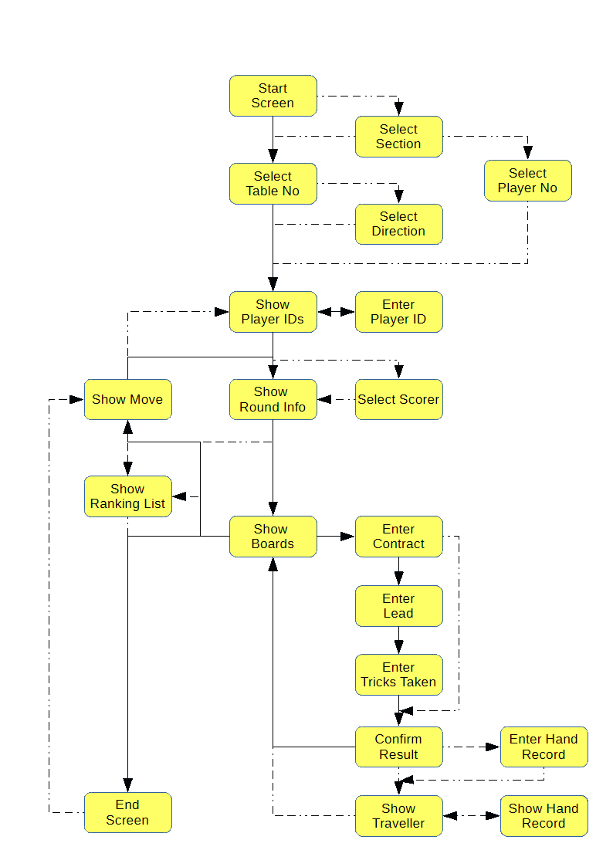
Appendix 2 – TabScore2 Workflow Diagram
Main Flow
Optional Flow

Appendix 3 – Setting Up Tablets
Bedford Bridge Club uses dedicated tablets with the following software: Fully-Kiosk-Browser-v1.28.1; Nova Launcher_v5.5.4 and Icon Changer_v2.0.
This has been configured as follows:
- Set Nova Laucher as the default start app.
- Set the following settings in Nova Launcher:
  - Desktop/Desktop grid 4x4
  - Desktop/Icon size/Font size = about 75%
  - Desktop/Wallpaper scrolling off
  - App & widget drawers/Frequently used apps off
  - Dock/Enable off
  - Look & feel/Normalize icon size off

  - Look & feel/Screen orientation Force Portrait
  - Look & feel/Show notification bar off
- Using Icon Changer, set the Fully icon to TabScore2.png (included in zip file) and set label to TabScore2.
- Delete all icons from desktop except TabScore2'
- Set wallpaper to something suitable. Bedford Bridge Club has created it's own wallpaper as you can see in this image.
- Set Fully start URL to static IP address of laptop + /TabScore2
- Set Fully/Web Zoom and Scaling/Set Font Size = 150% (or whatever best suits your device).
It is possible to use the Fully setting Device Management/Launch on Boot to start Fully automatically when the tablet is switched on. And you can also use Nova Launcher to lock the desktop to prevent users moving things around.

Appendix 4 – Setting Up Kindles
The information below has been provided by Tony Ferneyhough, and relates to Kindle Fire gen 5 upwards and Fully kiosk browser.
From Main Menu

- Web Content Setting
Start URL (PC IP address - eg 192.168.20.50)

- Web Browser Settings
Enable Tap Sound (optional)
Animate Page Transitions (optional)
Wait for Network Connection ( optional – maybe)

- Web Zooming and Scaling
View in Desktop Mode
Set Font Size (135 in my case) (Font size can also be set on tablet)

- Advanced Web Settings
Enable Touch Interaction
Keep Screen on whilst in Full screen mode

- Universal Launcher
All set to off

- Web Auto Reload
Reload Current Page (not too sure how important this is)

- Toolbar and Appearance
Show Action Bar
Action Bar Title - preferred name - TabScore2 - about 40 spaces before name to help centre title up.
ShowAction Bar in Settings
Show Progress Bar

- Screensaver (Plus)
Screensaver Timer (set to 10 seconds) (when running screen goes black only ’skeleton’ clock showing - this should help to save power). Tap screen to go back to TabScore2.***
Play in Full Screen
Screensaver brightness (set to 60)
Fading Duration (set 50 mS)
Use Android Daydream - try turning this feature off if there are problems with Screensaver.***

- Device Management
Keep Screen on
Screen Brightness= 60
Screen Orientation is Portrait
Launch at Boot
Bluetooth – disable

- Power Settings
Set battery to 30%

- Kiosk Mode - only use this when everything else is working okay !!!!
Kiosk exit (fast 5 taps)
Disable Status Bar
Disable Volume Buttons
Disable Power Button (optional)
Disable Home Button
Disable Other Apps
Advanced Kiosk Protection
Diable camera

- Motion Detection (Plus) All set to off

- Device Movement Detection (Plus) All set to off

- Remote Administration (Plus) All set to off

- Other Settings All set to off

